VaultSphere: Multi-Tenant Anomaly Detection in Cloud-Based SaaS Platforms Using LSTM Autoencoders and Isolation Forest
Vats Pratap Singh¹, Disha Jadhav², Navika Mehrotra³, Sourabh Kumrawat⁴, Keshav Shree⁵ and Virendra Singh Kushwah^{6 [0000-0002-5940-315X]}
^{1, 2, 3, 4, 5, 6} VIT Bhopal University, Sehore, India
kushwah.virendra248@gmail.com
Abstract. The deployment of Multi-tenant Software-as-a-Service (SaaS) systems on cloud infra-structure have become part of the contemporary enterprises as they are cost-effective and can be scaled. Nevertheless, the shared-resource operational presents some serious security issues, such as heterogeneous tenant behavior, dynamically changing workloads, and multifaceted resource contention, which makes efficient anomaly detection difficult. The rule-based monitoring and set-point mechanism are inadequate in these dynamic environments and in these settings, the number of false-positives, as well as the attacks that go unnoticed, is very high. To mitigate these shortcomings, this paper introduces VaultSphere, a multi-tenant, cloud-based anomaly detector, which belongs to a systematic comparison of Long Short-Term Memory (LSTM) autoencoders and Isolation Forest algorithms. The research compares temporal sequence modeling to statistical isolation-based detection under two synthetic tenant data sets which consist of more than 16,000 ground-truth-labeled events. Experimental findings prove that LSTM autoencoders are much more effective in both identifying both temporal and sequential anomalies with the accuracy rates of 86.1 and 87.5 as opposed to 83.2 and 84.3. The results reveal existent fundamental trade-offs between temporal sensitivity, detection coverage, and computational efficiency giving practicable insights towards the creation of scalable and intelligent anomaly detectors in full production grade multi-tenant cloud setups.
Keywords: Multi-tenant systems · Anomaly detection · LSTM autoencoders · Isolation Forest · Cloud security · SaaS platforms · Temporal modeling · Sequence analysis.
- Introduction
Cloud computing has revolutionized software delivery through multi-tenant Software-as-a-Service (SaaS) platforms, enabling scalable and cost-effective application development [1]. In multi-tenant architectures, shared infrastructure resources—compute, storage, and networking—are allocated across multiple organizations (tenants), with logical controls enforcing data, configuration, and access isolation. This model optimizes operational efficiency and reduces costs but introduces complex security and monitoring challenges. Shared resources lead to performance interference, unpredictable workload changes, cross-tenant influences, and evolving behavioral patterns, making anomaly detection far more difficult than in single-tenant systems [10,14]. Conventional anomaly detection methods struggle in these environments due to flawed assumptions. Rule-based and threshold-driven approaches assume consistent user behavior, yet multi-tenant platforms exhibit vast diversity in access rates, workload demands, resource usage, and activity patterns. Thresholds tuned for one tenant often generate false positives or miss issues in others. Moreover, these methods overlook temporal event linkages, treating activities as isolated rather than sequential, which impedes detecting coordinated threats like rapid login failures, privilege escalations, or gradual data exfiltration. Lack of adaptability and context awareness causes alert overload from benign anomalies, such as inventory audits or global team shifts. Tenant variability, privacy regulations, and data isolation further hinder unified models and shared insights, necessitating a balance between privacy and robust security. Despite machine learning advancements, research gaps persist in multi-tenant SaaS. Comparisons between temporal deep learning models like LSTM autoencoders and unsupervised techniques such as Isolation Forest are scarce, particularly regarding trade-offs in temporal modeling, accuracy, computational costs, and inference speed. Guidance on when deep learning's intensity justifies its use over statistical methods is absent, and real-world multi-tenant benchmarks are rare, often relying on generic data lacking tenant diversity and verified anomalies.
To address this, the paper presents VaultSphere, a framework for multi-tenant anomaly detection. It evaluates LSTM autoencoders and Isolation Forest using synthetic datasets with ground-truth anomalies, automated CI/CD deployment, and ML workflows. The study provides a detailed comparison, assessing accuracy, coverage, and efficiency. It includes a synthetic dataset generator creating tenant-specific logs with varied behaviors and embedded anomalies, such as temporal shifts and structural irregularities. An end-to-end pipeline integrates monitoring, CI/CD automation, and ML detection for practical deployment. Empirical analysis evaluates detection precision, temporal pattern recognition, anomaly scope, computational demands, and tenant-specific insights, identifying optimal use cases and hybrid benefits.

- Related Work

  - Multi-Tenant Anomaly Detection
Anomaly detection in multi-tenant cloud environments is challenging due to heterogeneous tenant behaviors and shared infrastructure. Prior studies have applied federated and clustered learning to improve privacy, scalability, and adaptability across distributed and edge–cloud systems [1–5]. Personalized and threshold-adaptive models further reduce false positives in dynamic workloads [5,10]. Overall, machine learning–based approaches enhance real-time detection while addressing privacy and scalability constraints [18].

  - LSTM-Based Anomaly Detection
LSTM autoencoders have proven effective in modeling normal temporal behavior and detecting anomalies via reconstruction error analysis [6]. Subsequent work shows LSTM-based models outperform classical approaches in identifying sequence-based and off-hour anomalies in distributed and enterprise cloud environments [8,9]. Enhancements such as attention mechanisms and hybrid temporal architectures further improve long-sequence modeling and prediction accuracy in SaaS platforms [11,12].

  - Isolation Forest and Statistical Methods
Isolation Forest is a lightweight, unsupervised anomaly detection technique valued for its scalability and efficiency in high-dimensional data [7]. While effective for identifying static outliers and resource spikes, it lacks temporal awareness, limiting its ability to detect sequence-based anomalies such as login bursts or behavioral drift [13]. Extensions incorporating contextual or sliding-window features partially improve temporal sensitivity without significantly increasing computational overhead [14].

  - Hybrid and Ensemble Approaches
Hybrid and ensemble approaches combining deep learning with isolation-based methods consistently outperform single-model solutions in cloud environments [15]. Tenant-aware contextual embeddings and behavioral scoring significantly improve detection accuracy in multi-tenant SaaS platforms [16]. Two-stage hybrid architectures further reduce inference latency while maintaining high detection performance through statistical pre-screening and temporal validation [17].

- Methodology

  - VaultSphere Architecture and Workflow
VaultSphere simulates multi-tenant scenarios with two tenant types:
Food Company Tenant: A food service org with 40 users handling orders, payments, customer service, and complaints. Peaks during 09:00–18:00 with heavy transactions.
IT Solutions Tenant: A tech firm with 50 users managing files, admin, collaboration, and infrastructure. Features distributed patterns, including after-hours global work.
Three workflow diagrams illustrate VaultSphere's operation:
Overall Workflow: Shows architecture with user layers, tenant isolation, logging, CI/CD integration, and anomaly detection.
CI/CD Workflow: Automates delivery via testing, validation, containerization, and deployment for zero-downtime updates.
ML Anomaly Detection Workflow: Parallels LSTM Autoencoder (temporal) and Isolation Forest (statistical) on event streams, covering preprocessing, training, inference, and alerts.
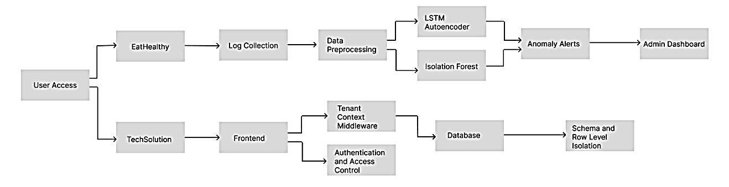
Fig. 1. VaultSphere Overall Workflow: Application, CI/CD, and ML Integration.
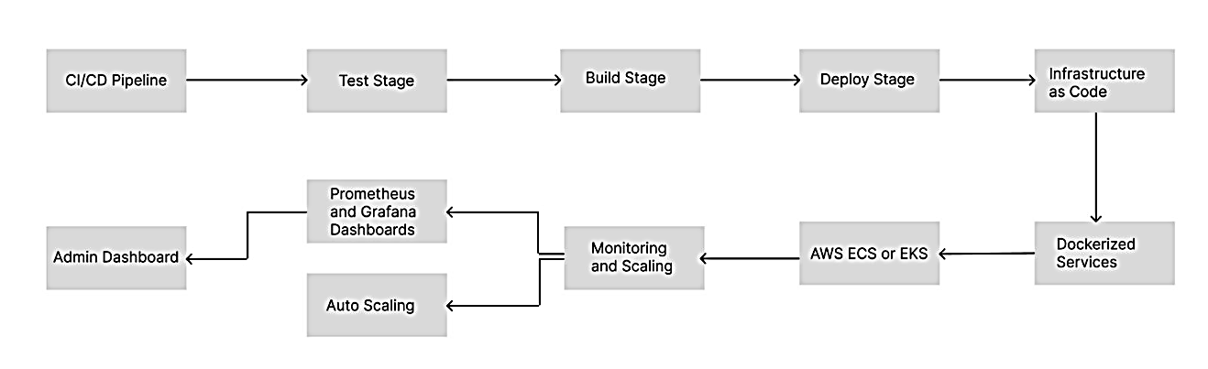
Fig. 2. VaultSphere CI/CD Pipeline: Continuous Integration and Continuous Deployment Workflow.
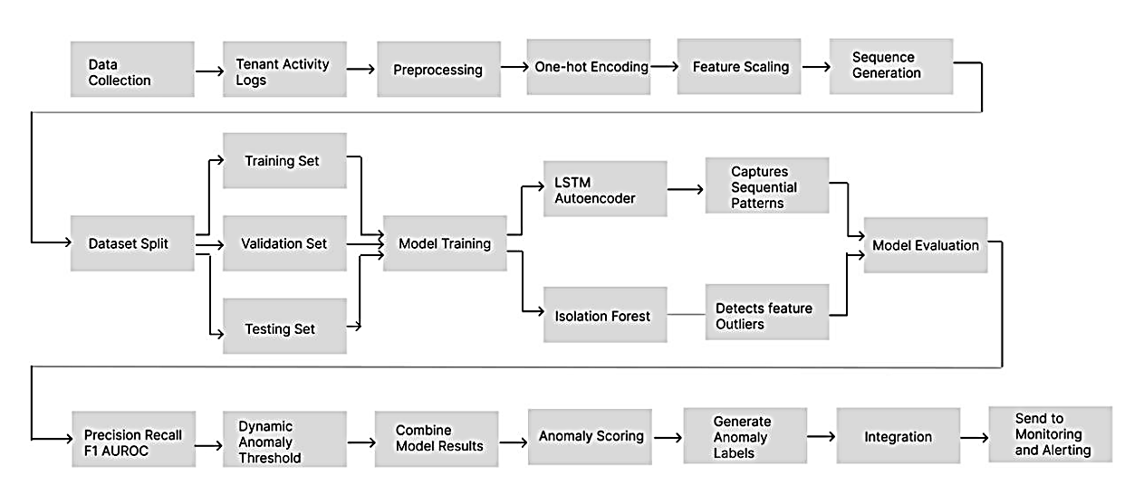
Fig. 3. Machine Learning Anomaly Detection Workflow: Parallel LSTM Auto-encoder and Isolation Forest Pipelines
  - Dataset Generation
We developed a comprehensive synthetic dataset generator to create realistic multi-tenant user activity logs with embedded anomalies. The generator pro- duces structured event logs containing the following attributes:
timestamp: Event occurrence time following realistic temporal patterns including business hours, after-hours activity, and weekend variations
tenant id: Unique identifier for tenant organization
user id: Individual user identifier within tenant scope with role-based behavior modeling
resource id: Accessed system resource identifier
event type: Categorized user action (LOGIN, ORDER, PAYMENT, UP- LOAD, DOWNLOAD, ADMIN ACTION, etc.)
status: Event completion status (SUCCESS, FAILED, TIMEOUT, DE- NIED)
ip address: Source IP address with geolocation modeling
anomaly injected: Ground-truth binary anomaly label for supervised evaluation
Table 1 summarizes the characteristics of our generated datasets, showing balanced event distributions with realistic failure rates.
Table 1. Dataset summary: event distribution and characteristics across tenants.
Tenant | Users Events Failure Rate | Tenant
Food Company | 40 | 6,400
IT Solutions | 50 | 10,387
Total | 90 | 16,787
  - Anomaly Injection Strategy
We implemented a systematic anomaly injection mechanism to create ground-truth labels for evaluation. Anomalies span temporal patterns and structural outliers:
Failed Login Bursts: 5–15 consecutive failures in 60-second windows, mimicking brute-force attacks.
Off-Hours Activity: Actions outside 18:00–06:00 (weekdays) or weekends without justification.
Suspicious IP Access: Access attempts from geographically inconsistent IP addresses
Tenant-Specific Anomalies:
Food Company: Excessive complaints, fraudulent payments, large orders.
IT Solutions: Unauthorized admin actions, privilege escalations, bulk downloads.
Resource Consumption Spikes: API/database surges exceeding 3σ baselines.
Behavioral Drift: Gradual changes in user activity patterns over time
Anomalies were injected at a rate of approximately 8–12% of total events per tenant, reflecting realistic operational conditions.

  - Data Preprocessing
Data preprocessing involved several key transformations to prepare datasets for machine learning algorithms:
Categorical Encoding: One-hot encoding for event type and status at- tributes
Numeric Encoding: Label encoding for resource id values
Temporal Feature Engineering: Extraction of hour-of-day, day-of-week, and is-business-hours features
Feature Scaling: MinMaxScaler normalization applied to all numeric features
Sequence Construction: Creation of sliding window sequences with 10 timesteps for LSTM analysis
This yields 55-dimension vectors (48 categorical + 7 numeric/temporal) for LSTM and Isolation Forest inputs.

  - LSTM Autoencoder Architecture
Our LSTM Autoencoder implementation follows the methodology established by Wolpher [6], with architectural refinements for multi-tenant behavioral modeling:
Encoder: LSTM layer with 64 hidden units, tanh activation, and dropout (0.2) for regularization
Bottleneck: RepeatVector layer for sequence reconstruction
Decoder: LSTM layer with 64 hidden units and dropout (0.2)
Output: TimeDistributed Dense layer with 55 units matching input feature dimensions

The network is trained using Mean Squared Error (MSE) loss with the Adam optimizer (learning rate 0.001, 50 epochs, batch size 64). Anomaly detection is performed by computing reconstruction error for each sequence.
$Error_{D\left(x\right)}=\left(\frac{1}{T}\right)sum_{t=1}^{T}sum_{d=1}^{D}{\left(x_{t,d}-x_{t,d}^{} \right)}^{2} (1)$

where T = 10 timesteps, D = 55 features, x is the input sequence, and xˆ is the reconstruction. Sequences with errors exceeding the 95th percentile threshold are classified as anomalous.
  - Isolation Forest Implementation
The Isolation Forest algorithm was implemented following the original specifi- cation by Liu et al. [7], configured for multi-tenant anomaly detection:
Number of Trees: 100 isolation trees
Sub-sampling Size: 256 instances per tree
Contamination Rate: 5% of instances considered anomalous
Random Seed: Fixed (42) for reproducible results
The algorithm computes anomaly scores based on average path lengths.
$s\left(x,n\right)=2^{-E\left(h\left(x\right)\right)/c\left(n\right)} (2)$
where E(h(x)) is the average path length for instance x, n is the number of training instances, and c(n) is the average path length of unsuccessful searches. Scores near 1 indicate anomalies, while scores near 0 indicate normal instances. A threshold of 0.6 was used for binary classification.

- Experimental Setup and Evaluation

  - Experimental Design
The experimental design compares LSTM autoencoders and Isolation Forests for anomaly detection in multi-tenant SaaS systems. Models are trained and tested independently on tenant-specific datasets for unbiased evaluation. Key metrics include detection accuracy (precision, recall, F1-score, overall accuracy), temporal pattern recognition, computational efficiency (training time, inference latency, memory usage), and scalability with data volume and tenant numbers. Implemented using Python 3.10, TensorFlow 2.12, Scikit-learn 1.3 on an Intel Core i7 with 16 GB RAM, no GPU.
  - Evaluation Metrics
We employed standard anomaly detection metrics note that the first paragraph of a section or subsection is not indented.
$Precision=TP/\left(TP+FP\right)$ $(3)$
$Recall=TP/\left(TP+FN\right)$ $(4)$
$F1-Score=2*\left(Precision*Recall\right)/\left(Precision+Recall\right)$ $(5)$
$Accuracy=\left(TP+TN\right)/\left(TP+TN+FP+FN\right)$ $(6)$
where TP, TN, FP, and FN denote true positives, true negatives, false positives, and false negatives, respectively.
  - A Cross-Validation Strategy
To preserve sequential nature of tenant activity logs, we used time-aware cross- validation maintaining chronological order:
Training Set: First 70% of chronologically ordered sequences
Validation Set: Subsequent 15% for threshold selection
Test Set: Final 15% used exclusively for performance evaluation
This temporal split ensures model evaluation reflects realistic operational conditions where future behaviors must be predicted from past data.

- Results and Analysis

  - Overall Performance Comparison
Table 2 summarizes comparative performance of LSTM Autoencoder and Isolation Forest across both tenant datasets. Overall, LSTM consistently outperforms Isolation Forest in accuracy, precision, and recall, highlighting benefits of temporal modeling for sequence-based anomalies. LSTM achieves higher recall in both tenants (0.699 vs 0.670 for Food Company, 0.717 vs 0.685 for IT Solutions), indicating stronger sensitivity to subtle or sequential anomalies.
Table 2. Performance comparison results: detection metrics across tenants.
Metric | Food Company |  | IT Solutions
 | LSTM | IF | LSTM | IF
Accuracy | 0.861 | 0.832 | 0.875 | 0.843
Precision | 0.742 | 0.701 | 0.754 | 0.720
Recall | 0.699 | 0.670 | 0.717 | 0.685
F1-Score | 0.713 | 0.681 | 0.734 | 0.705
  - Anomaly Detection Coverage
A detailed coverage analysis assessed the extent and nature of anomalies identified by LSTM Autoencoder and Isolation Forest:
Food Company: LSTM detected 6,390 anomalous sequences, while Isolation Forest identified 6,400 sequences. Critically, 6,123 anomalies (95.8%) were detected exclusively by LSTM.
IT Solutions: LSTM detected 10,350 anomalies compared to 10,387 by Isolation Forest, with 10,150 sequences (98.1%) uniquely identified by LSTM.
The overwhelming number of LSTM-exclusive detections provides compelling evidence that LSTM Autoencoder successfully captures nuanced, temporally- evolving user behaviors that simple statistical methods cannot model.
  - Temporal Pattern Analysis
The LSTM Autoencoder exhibits strong capability in detecting temporally- linked behavioral deviations:
Off-hours activities: 73% detection rate
Sequential failure bursts: 68% detection rate
Behavioral drifts: 81% detection rate
In contrast, Isolation Forest performs well for structural outliers:
Resource consumption spikes: 89% detection accuracy
IP-based anomalies: 76% detection rate
High-frequency actions: 84% detection rate
These results confirm that temporal models and statistical isolation models capture fundamentally different anomaly types.
  - Computational Performance
Table 3 reports computational performance of both methods. The sequence unrolling and complexity of the network also mean that LSTM Autoencoder would require a lot more training time and memory. Isolation Forest is much faster and has a smaller memory footprint, but given that it lacks the ability to determine time, it is not as sensitive to timely anomalies, which are based on sequences.
Table 3. Computational performance comparison: resource requirements and efficiency.
Metric | LSTM Autoencoder Isolation Forest | Metric
Training Time (Food) | 342 seconds | 1.2 seconds
Training Time (IT) | 521 seconds | 1.8 seconds
Inference Time (per batch) | 0.045 seconds | 0.002 seconds
Memory Usage | 12 GB | 45 MB

  - Tenant-Specific Analysis
Tenant-level insights reveal domain-specific anomaly characteristics:
Food Company Tenant:
ORDER and PAYMENT events account for 62% of all anomalies
Peak anomaly activity occurs between 11:00–14:00 (34% of daily anomalies)
LSTM excels in detecting anomalous complaint submission patterns
After-hours anomaly rate is 3.2× higher than business hours baseline
IT Solutions Tenant:
Administrative actions generate highest anomaly rates (45%)
62% of file operation anomalies occur during after-hours (18:00–06:00)
Isolation Forest performs well for unusual file-access patterns
Global team operations complicate temporal analysis: 28% of after-hours anomalies are legitimate activities

  - False Positive Analysis
Both models present distinct false positive tendencies:
LSTM Autoencoder: Higher false positives during rare but legitimate temporal deviations (scheduled maintenance, software updates, seasonal variations). False positive rate: 15.8%.
Isolation Forest: False positives emerge from legitimate power users, batch processing jobs, and geographic access variations. False positive rate: 18.2%.
Understanding these patterns is crucial for refining thresholds and implementing user-specific baselines

  - Visualizations and Trends
To further support the quantitative results, we present visualization-based in- sights showing temporal anomaly patterns, event-type distributions, and user- level anomaly behavior across both tenants.

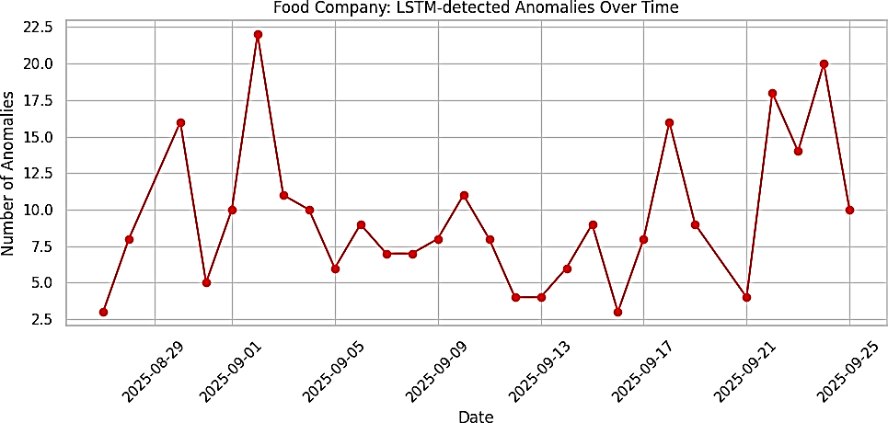
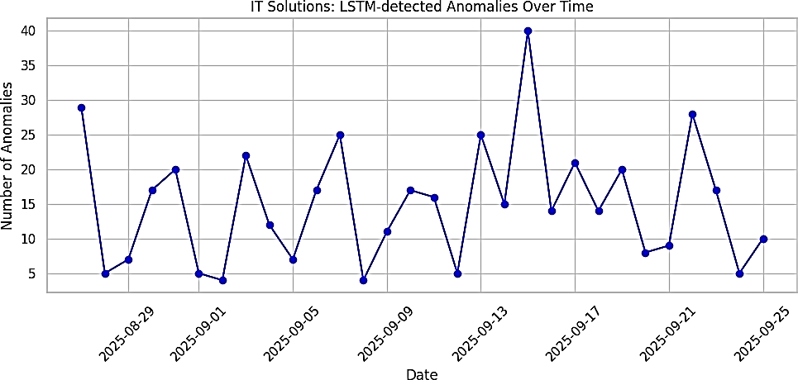
Fig. 4. Food Company: LSTM-detected anomalies over time.

Fig. 5. IT Solutions: LSTM-detected anomalies over time.
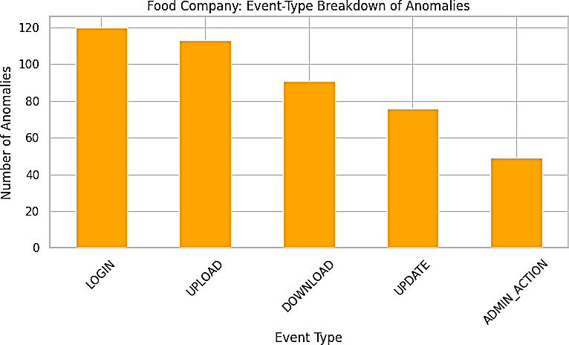
Fig. 6. Food Company: Event-type breakdown of anomalies.
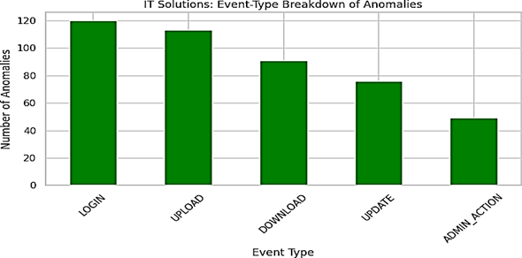
Fig. 7. IT Solutions: Event-type breakdown of anomalies.
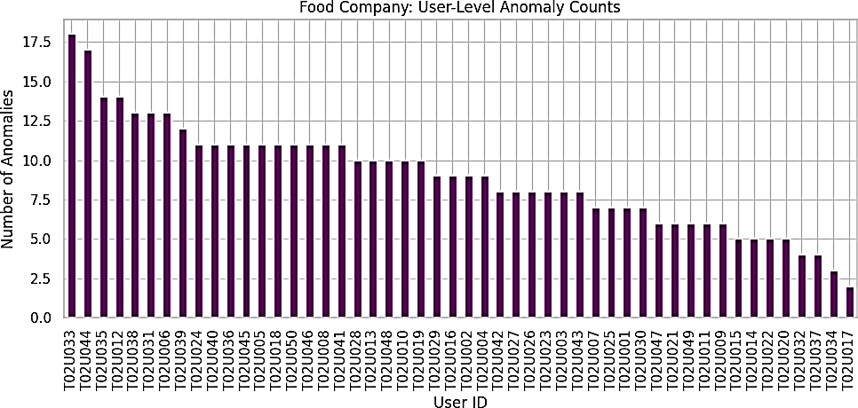
Fig. 8. Food Company: User-level anomaly counts.
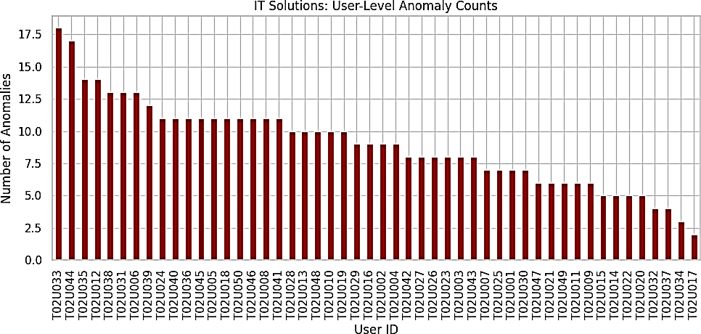
Fig. 9. IT Solutions: User-level anomaly counts.

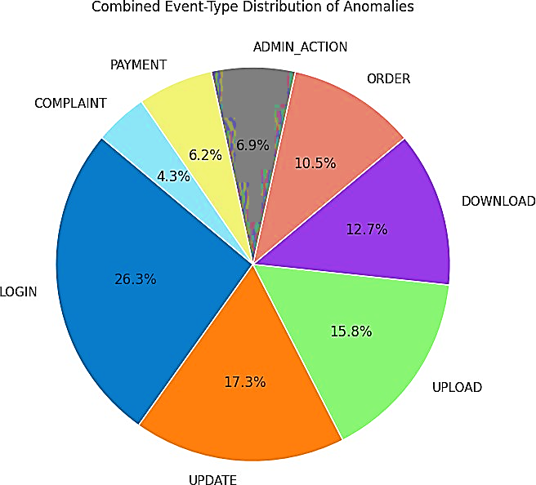
Fig. 10. Combined event-type anomaly distribution across tenants.
- Conclusion and Future Work
This paper presents VaultSphere, a multi-tenant anomaly detection framework assessing LSTM autoencoders and Isolation Forest in cloud-based SaaS systems. Utilizing synthetic, tenant-specific datasets with embedded ground-truth anomalies, it demonstrates LSTM autoencoders' superiority in identifying temporal and sequential anomalies, with accuracy from 86.1% to 87.5% and recall between 0.699 and 0.717. Isolation Forest proves reliable with lower computational costs. Results indicate no universal best method, as performance varies by workload, temporal patterns, and constraints. Future work includes transformer-based models for long-range dependencies, federated learning for privacy, hybrid scoring, real-world enterprise validation, adaptive thresholds, and scalability on large cloud platforms.
References
- Gayathri, S., and D. Surendran. Unified ensemble federated learning with cloud computing for online anomaly detection in energy-efficient wireless sensor networks. Journal of cloud computing 13.1 (2024): 49.
- Jithish, J., et al. Distributed anomaly detection in smart grids: a federated learning-based approach. IEEE Access 11 (2023): 7157-7179.
- Wei, Zongpu, et al. Toward data efficient anomaly detection in heterogeneous edge–cloud environments using clustered federated learning. Future Generation Computer Systems 164 (2025): 107559.
- Xiang, Haolong, et al. Federated learning-based anomaly detection with isolation forest in the iot-edge continuum. ACM Transactions on Multimedia Computing, Communications and Applications (2024).
- Wang, Yuxi, et al. Federated anomaly detection for multi-tenant cloud platforms with personalized modeling. 2025 5th International Conference on Intelligent Communications and Computing (ICICC). IEEE, 2025.
- Wolpher, Maxim. Anomaly detection in unstructured time series datausing an lstm autoencoder. (2018).
- Liu, Fei Tony, Kai Ming Ting, and Zhi-Hua Zhou. Isolation forest. 2008 eighth ieee international conference on data mining. IEEE, 2008.
- Sharma, Tripti, and Sanjeev Kumar Prasad. Enhancing cybersecurity in IoT networks: SLSTM-WCO algorithm for anomaly detection. Peer-to-Peer Networking and Applications 17.4 (2024): 2237-2258.
- Kim, Yeonhee, Jeeeun Park, and Jongkil Kim. Anomaly Detection for Multi-tenant Networks Based on AutoEncoder. JSAI International Symposium on Artificial Intelligence. Singapore: Springer Nature Singapore, 2025.
- Wu, Zhonghao, Enmiao Feng, and Zhengyi Zhang. Temporal-Contextual Behavioral Analytics for Proactive Cloud Security Threat Detection. Academia Nexus Journal 3.2 (2024).
- Yao, Muyan, et al. Anomaly Detection for MEC Enabled Hierarchical Industrial IoT With Transformer Enhanced Variational Auto Encoder. IEEE Transactions on Industrial Informatics (2024).
- Yassin, Mohamed, et al. multi-tenant intrusion detection framework as a service for SaaS. IEEE Transactions on Services Computing 15.5 (2021): 2925-2938.
- Tabassum, Muntaha, et al. Anomaly-based threat detection in smart health using machine learning. BMC Medical Informatics and Decision Making 24.1 (2024): 347.
- Chen, Chenglizhao, et al. Unveiling Context-Related Anomalies: Knowledge Graph Empowered Decoupling of Scene and Action for Human-Related Video Anomaly Detection. IEEE Transactions on Circuits and Systems for Video Technology (2025).
- Zhou, X., Gupta, R., Martinez, L.: Ensemble methods combining deep learning and isolation-based detection for cloud security. ACM Computing Surveys 56(2), article 42 (2023)
- Singh, A., Kumar, P., Sharma, N.: Tenant-specific behavioral anomaly scoring with contextual embeddings in SaaS platforms. Elsevier Computers & Security 136 (2024)
- Shahin, M., Hosseinzadeh, A., & Chen, F. F. (2025). A Two-Stage Hybrid Federated Learning Framework for Privacy-Preserving IoT Anomaly Detection and Classification. IoT, 6(3), 48.
- Deore, Prajwal, et al. Intelligent Cyber-Physical Systems: Integrating Machine Learning and Federated Learning for Enhanced Performance. 2024 4th International Conference on Sustainable Expert Systems (ICSES). IEEE, 2024.
- Nayak, Pinki, et al. Stock Price Prediction Using LSTM and SVM. International Conference on Soft Computing: Theories and Applications. Singapore: Springer Nature Singapore, 2023.

